**ASSIGNMENT NO. 10**

**TEMPLATE FOR MINI PROJECT REPORT**

**(Font: Times New Roman, Font Size: for title-14, for Content-12)**

Cover page-

Index

| **Chapter** | **Contents** | | **Page No.** |
| --- | --- | --- | --- |
| 1. |  | Introduction |  |
|  | *a.* | Problem Statement |  |
|  | b. | Project Idea |  |

List of Figures & Tables

| **Figure/Table No.** | **Figure/ Table Name** | **Page No.** |
| --- | --- | --- |
| 1 |  |  |
| 2 |  |  |

**Chapter 1:** Introduction

1. Problem Statement
2. Project Idea/ Objectives
3. Motivation
4. Scope

**Chapter 2:** Requirement Analysis

**Chapter 3:** Project Design

* 1. H/W , S/W , resources, requirements & their detail explanation
  2. Dataset Design
  3. Architecture

**Chapter 4:** Results (Screenshots)

**Chapter 5:** Conclusion

**A PRELIMINARY MINI PROJECT REPORT ON**

**“Title of the Project (Font: 14)”**

**SUBMITTED TOWARDS THE PARTIAL FULFILLMENT OF THE REQUIREMENTS OF**

**BACHELOR OF ENGINEERING (T.Y. B. Tech.)**

**Academic Year: 2023-24**

**By:**

**<Name of students in group with PRN No>**





**Under The Guidance of**

# **<Mrs. S**mitaC. Khairnar**>**

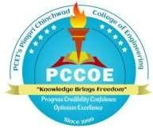

**DEPARTMENT OF COMPUTER ENGINEERING, PIMPRI CHINCHWAD COLLEGE OF ENGINEERING SECTOR 26, NIGDI, PRADHIKARAN**

**TEMPLATE FOR PROJECT CERTIFICATE:**

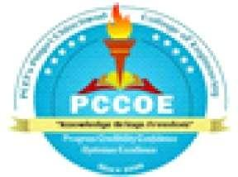

PIMPRI CHINCHWAD COLLEGE OF ENGINEERING

DEPARTMENT OF COMPUTER ENGINEERING

# **CERTIFICATE**

## This is to certify that, the project entitled

**“** _(Bold)” is successfully carried out as a **Skill Development Laboratory I** mini

## project and successf

Chinchw

# **Under t**

lly submitted by following students of “PCET's Pimpri d College of Engineering, Nigdi, Pune-44**”.**

# **e guidance of Mr. /Mrs. /Dr.**

In the partial fulfillment of the requirements for the T.Y. B. Tech. (Computer Engineering)

# **<Name of students in group with Roll No., PRN No.>**

**_**

**_**

# **Mrs. Smita K**hairnar

# **Project Guide**